**Module Assignment**

**Module 2**

**QMB-6304 Analytical Methods for Business**

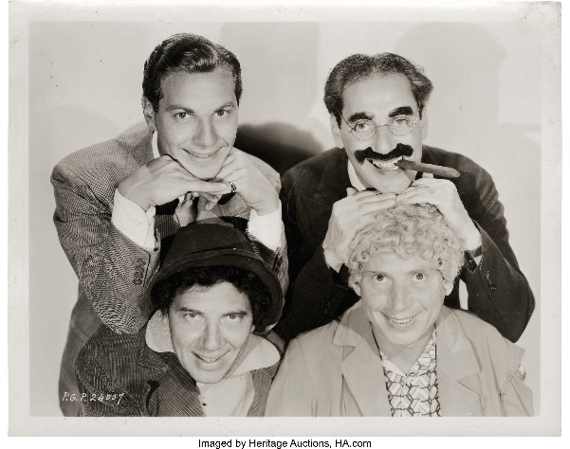Write a simple R script to execute the following:

**Preprocessing:**

Load the data in “6304 Assignment 2 Data.xlsx” into an object. The file includes 10000 observations for each of four variables, which are creatively named after four of the Marx Brothers.

**Analysis:**

1. Use common tools to determine whether any of the four variables are normally distributed. Explain how you arrived at your conclusions.
2. For those variables which you deem to NOT be normally distributed discuss what kind of distribution you believe that data follows.
3. Focus on the Groucho variable. Build a sampling distribution of the population mean by calculating the mean for each of 1000 samples of n=50. Plot the sampling distribution with an appropriate graph title. Verify whether these 1000 means are in fact normally distributed as the Central Limit Theorem states. Justify your conclusion with appropriate analytics and/or graphical tools.

Your deliverable will be a single MS-Word file showing 1) the R script which executes the above instructions and 2) the results of those instructions. The first line of your script file should be a “#” comment line showing your name as it appears in Canvas. Results should be presented in the order in which they are listed here. Deliverable due time will be announced in class and on Canvas. **This is an individual assignment to be completed you leave the classroom. No collaboration of any sort is allowed on this assignment.**